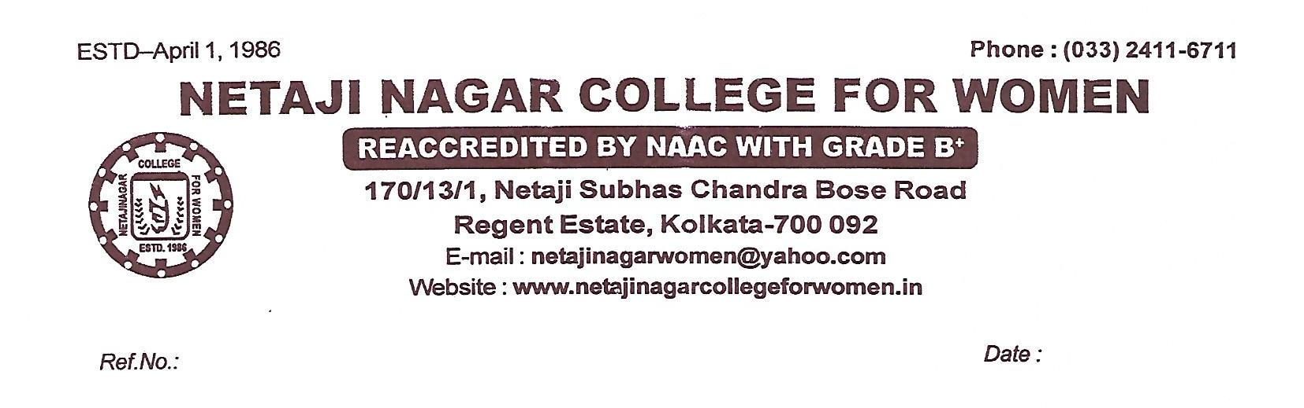

DETAILS OF SUSPENDED STAFF, IF ANY , AT YOUR INSTITUTION as per No. GRC-HED/02!10)/24 DATED 29.08.2024
NAME OF THE SUSPENDED  EMPLOYEE | NAME OF THE OFFICE / INSTITUTION  WITH ADDRESS | SUSPENDED  FROM | REASON FOR  SUSPENSION | ANY OTHER DETAILS
NA | NETAJI NAGAR COLLEGE FOR WOMEN | NA | NA | NA
 | 170/13/1 N.S.C BOSE ROAD
 | REGENT ESTATE, KOLKATA-700092
PLEASE SEND THE DETAIL IN PDF AND WORD (SOFT COPY) ALSO TO EMAIL ID grievance.hed.wb@gmail.com BY13.09.2024 POSITIVELY IF NO CASE IS AVIALABLE PLEASE MENTION NOT APPLICABLE ( NA)

